Impressionism in Australia

Although Australian colonial artists were aware of French Impressionism in the mid-1880s, their understanding of the term derived from reading European sources and seeing poor black-and-white reproductions, rather than from experiencing the actual paintings themselves. As Impressionism was to them more an idea than a method, they abandoned their studios to paint contemporary subjects out-of-doors—capturing not only the Australian landscape and way of life but also the clarity of Australian light—without reference to the specific colour techniques of French Impressionism. This apparent rejection of traditional art practice happened to coincide with the rise in nationalist sentiment associated with the 1888 centenary of European settlement in Australia. The concepts of naturalism and nationalism were therefore conflated and Australian impressionist painting became synonymous with Australian national identity. The term Australian Impressionism is usually reserved for a particular group of artists associated with the National Gallery of Victoria School, who gathered to paint en plein air in semi-rural districts close to Melbourne. The group is widely known as The Heidelberg School, a name coined in 1889 by the critic Sidney Dickinson (1851-1919) after the location of a second camp on Melbourne’s fringe that was temporary home to Arthur Streeton (1867-1943) and frequented by Tom Roberts (1856-1931) and Charles Conder (1868-1909).

The first of this group’s informal weekend camps was set up at Box Hill in late 1885 by Roberts, Fred McCubbin (1855-1917) and Louis Abrahams (1852-1903), where they and their fellow artists painted closely-focused intimate glimpses of the surrounding bush. [IMAGE 1] The landscapes painted from 1888 at the later Heidelberg camp were more expansive and characteristically coloured bright blue and gold (considered Australia’s national colours until green and gold were so proclaimed in 1984). [IMAGE 2] The key members of the so-called Heidelberg ‘school’ are usually given as Roberts, McCubbin, Streeton and Conder; however, in a group retrospective exhibition held at the National Gallery of Victoria in 2007, other usually overlooked artists were represented by the inclusion of a fifth and female addition: Jane Sutherland (1853-1928).

The fact that these artists identified themselves as impressionists can be seen in their 9 x 5 Impressionist Exhibition of 1889; a deliberately provocative exhibition of spontaneous sketches executed on small wooden cigar-box lids (hence the name ‘9 x 5’). Presumably the brainchild of Roberts (who promoted the event through his society contacts) and Conder (who designed the catalogue’s symbolist cover), the exhibition included over 180 exhibits that supposedly confirmed the accompanying statement that “An Effect is only momentary”. James Smith (critic for the Argus) dismissed both this interpretation of impressionism, and the individual works themselves, in words very similar to those used by Ruskin in his 1877 criticism of Whistler. Indeed, the 9 x 5 exhibition, with its emphasis on aesthetic display and colour harmonies, owed more to Whistler than to Monet and Renoir.

Following the growing recognition of impressionism as more than a French-based specialty but instead a world-wide modernist movement, the term Australian Impressionism now includes plein-airists who worked in Sydney where Julian Ashton (1851-1942) and Alfred Daplyn (1844-1926) had taught Conder in 1887, and where Tom Roberts and Arthur Streeton relocated in the 1890s. It also includes artists such as Walter Withers (1854-1914) and Emanuel Phillips Fox (1865-1915), who were still painting near Melbourne with the same fresh palette and loose brushwork long after the original Heidelberg foursome had gone their separate ways. Despite images such as Conder’s Holiday at Mentone [IMAGE 3]—which by any measure is an exemplar of fashionable urban modernity—impressionism to Australian eyes remains inextricably linked with nostalgic bush landscapes and national identity.

IMAGE 1

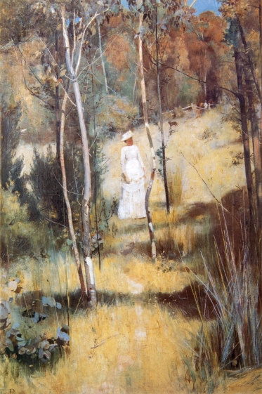
Tom Roberts, A Summer Morning Tiff 1886, Art Gallery of Ballarat

(Reproduction rights held by the Art Gallery of Ballarat
Email:artgal@ballarat.vic.gov.au)
or see
http://www.qagoma.qld.gov.au/__data/assets/image/0004/73822/2009.02_086PN.jpg

IMAGE 2

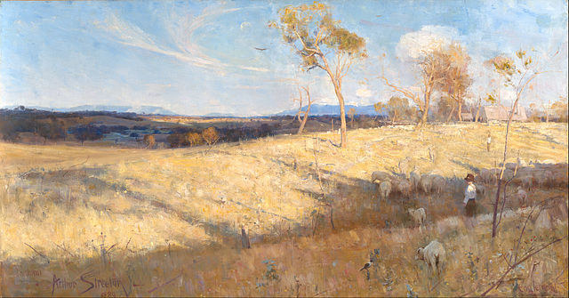
Arthur Streeton, Golden Summer, Eaglemont 1889, National Gallery of Australia

(http://artsearch.nga.gov.au/Detail.cfm?IRN=61325)

IMAGE 3

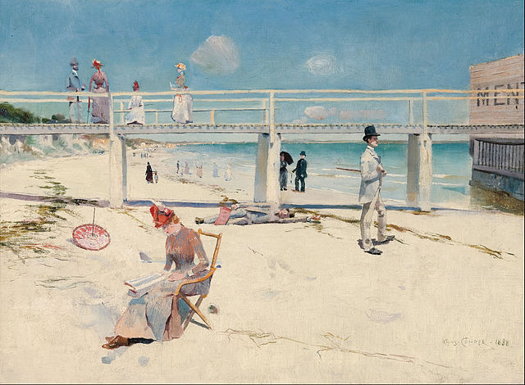
Charles Conder, Holiday at Mentone 1888, Art Gallery of South Australia

(http://www.artgallery.sa.gov.au/agsa/home/Collection/detail.jsp?ecatKey=1645)

REFERENCES AND FURTHER READING

Astbury, Leigh (1985) City Bushmen: The Heidelberg School and the Rural Mythology. Melbourne: Oxford University Press. (Essential reading for understanding the cultural and social issues—both local and international—that affected the emergence of Australian Impressionism.)

Clark, Jane, and Whitelaw, Bridget (1985) Golden Summers: Heidelberg and Beyond. Melbourne: International Cultural Corporation of Australia. (Scholarly catalogue of the exhibition that not only marked the centenary of the first Box Hill artists’ camp, but also the repatriation of Streeton’s iconic landscape, Golden Summer, Eaglemont 1889.)

Hammond, Victoria, and Peers, Juliet (1992). Completing the Picture: Women Artists and the Heidelberg Era, Melbourne: Artmoves. (Catalogue of the groundbreaking exhibition that redresses the gender imbalance of previous studies of Australian Impressionism.)

Lane, Terence (ed.) (2007) Australian Impressionism. Melbourne: National Gallery of Victoria. (Comprehensive catalogue of the retrospective exhibition that, in firmly replacing usage of the term Heidelberg School with Australian Impressionism, argues for a global rather than a provincial context for these artists and their work. Essential reading for its thematic scholarly essays and for its illustrations.)

Smith, James (1889) ‘An Impressionist Exhibition’, Argus (Melbourne), 17 August 1889, 10 (A critique of impressionism by Melbourne’s most influential art critic of the time. See http://trove.nla.gov.au/ndp/del/article/6271593 )

Spate, Virginia (1990) ‘The Sunny South: Australian Impressionism’, in Norma Broude (ed.) World Impressionism: The International Movement, 1860-1920. New York: H.N. Abrams, 114-35 (An important article that seriously analyzes Australian impressionism in a world-wide context.)

